April, 2017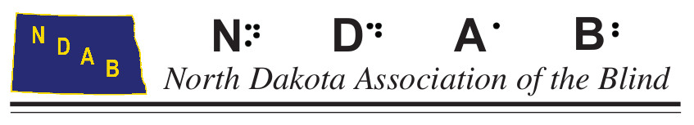

Dear Friends and Family of North Dakota Association of the Blind

It was 80 plus years ago, in the hot, drought year in August of 1936, when eleven “visionary” people, 9 of whom were blind, met in Jamestown to begin to organize our very own state-wide, independent, non-profit organization, which they named, the **North Dakota Association of the Blind** (**NDAB**).

To help celebrate our past 80 years of service, we’ve adopted the t-shirt slogan, **“Promoting independence since 1936”.** Yes, absolutely, NDAB has been very busy for the past 80 years, promoting independence for people through its service programs & advocating for policies to improve the lives of each and every person who experiences sight loss in North Dakota. Notably, our members have included people from every walk of life and from every community within our state.

If you were to ask, “among us in ND, how many today have a loss of eyesight”? The U.S. Census Bureau estimates that presently there are approximately 757,000 residents in North Dakota. Scientific statistical studies have consistently demonstrated that, conservatively, **3.3%** among the general population, will have conditions that mildly, moderately, or severely medically compromise their eyesight – this means that approximately **24,000** individuals in North Dakota are affected by **uncorrectable sight loss** - a quarter of whom (**6,000**) have **significant sight loss** and/or are **“legally blind**”.

To do our work, it’s vitally important that we, as a non-profit, generate our income from donations, grants, & fundraisers. The most popular and costly of the service programs that we offer is a Summer Camp for Adults. An average of 50 individuals attend. Cost per day is $50/person. A suggested guide for giving: a $50 donation covers costs for a day per person, 2 days X $50 = $100, Camp for 4 days X $50 = $200, a week = $350. **Above all know that donations of any size are welcomed & deeply appreciated**!

Make donations payable to: **North Dakota Association of the Blind** or **NDAB**. Donations may be used as an income tax deduction. For more info or to donate on-line visit [www.ndab.org](http://www.ndab.org/).

**THANK YOU** for your consideration! Questions? Call us,

Allan Peterson, NDAB Development Director

7009 Horseshoe Bend

Horace, ND 58047

Phone: (701) 282-4644

ND Charitable Solicitation License #: 1394 IRS 501c3 Tax # 23-7084473