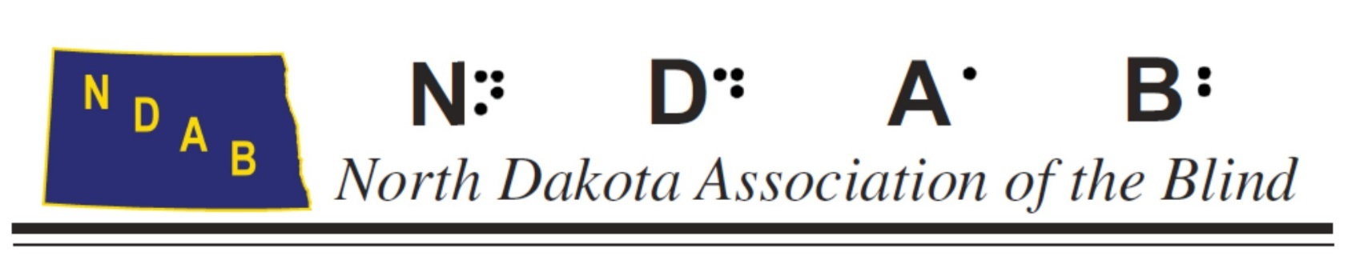

Olga Neal Teacher of the Visually Impaired Scholarship Program

The North Dakota Association of the Blind established the Olga Neal Teacher of the Visually Impaired Scholarship for the purpose of increasing and retaining the number of teachers in North Dakota who are fully qualified to provide services to students and adults with visual impairments through support of retraining efforts. Applicants must be residents of either North or South Dakota or enrolled in a university program in North or South Dakota.

North Dakota Association of the Blind will award a scholarship to an individual who wishes to pursue training in the field of Visual Impairment. All applications must be postmarked by March 15th and the winner will be announced at our annual convention in June.

This scholarship is in the amount of $2000. Information and applications will be sent to North and South Dakota Universities who offer courses related to visual impairment.

The scholarship recipient will be evaluated on the following factors:
- Completion of one semester in either an undergraduate or graduate approved program in Visual Impairment or Orientation and Mobility
- GPA of 3.0
- Letters of Recommendation

Other applicant information:
- Applicant must be enrolled either physically on campus or in an on-line program.
- Workshops or conferences are not considered coursework for this scholarship.
- Applicants in non-approved visual impairment and/or O&M programs will not be considered for a scholarship.
- Applications must be submitted by the specified deadline. Late or incomplete application packets will not be considered.
- Failure to complete coursework or program requirements will result in disqualification for future awards.
- Scholarship will be sent directly to the university providing the vision program. The university will dispense the funds to the person selected.

For more information contact Tracy Wicken at: trwicken@nd.gov

APPLICANT INSTRUCTIONS

The Scholarship Award Application Packet must be returned as a complete package and must include the following:

- Cover Letter stating:
- Applicant’s interest in an award
- Applicant’s current working status
- Where and what program the applicant is enrolled in
- The applicant’s employment plans following completion of coursework.
- A statement of the applicant’s commitment to education of students or adults with visual impairments in North Dakota.

- Scholarship Application Form

- Professional Recommendations: Two recommendation forms must be completed by current administrators, principals, supervisors or professors.

- Current Transcripts: Include all undergraduate and graduate level college work completed (copies are accepted)

- Program of Study: The program of study must be completed and signed by a university Advisor and must be included in the scholarship packet.

For general questions on the application process, contact Tracy Wicken at trwicken@nd.gov

NOTE: Applications must be postmarked by March 15. Incomplete application will not be considered. Please mail to:
Tracy Wicken
733 Dawn Circle
Grand Forks, ND 58203

OLGA NEAL TEACHER OF THE VISUALLY IMPAIRED SCHOLARSHIP APPLICATION

- Personal Data
(Please type or print all information)
Name:__________________________________________________________________
Address:________________________________________________________________
City, State, Zip/Postal Code:_________________________________________________
Day Time Phone #:_________________ Evening Phone #:________________________
Date of Birth:_______________(mm/dd/yyyy) Student ID Number________________

- Educational Background
- Educational Institution Attending:_________________________________________
City:________________________State____________Zip/Postal Code:______________
Cumulative Grade Point Average (based on a 4.0 scale):__________________________
Major:___________ Full or Part Time:__________ Number of Hours:_____________
Degree/Certificate Sought:______________ Date Degree Expected:_______________
School which you plan to attend in fall (if different from answer in A.
above):_________________________________________________________________
City:____________________State:____________Zip/Postal Code:_________________
Cumulative Grade Point Average (based on a 4.0 scale):__________________________
Major:___________ Full or Part Time:__________ Number of Hours:_____________
Degree/Certificate Sought:______________ Date Degree Expected:_______________
- List any other secondary or post-secondary school you have attended.
Name of Institution:______________________________________________________
City:__________________State:_____________Zip/Postal Code:__________________
Cumulative Grade Point Average (based on a 4.0 scale):__________________________
Dates Attended: From:____________(mm/yyyy) To:___________________(mm/yyyy)
Degree or Certificate Received:___________________(type & date)________________
(Attach additional sheets if you have attended additional secondary or post-secondary institutions.)
- Explain why you have chosen the field or course of study you are
pursuing. (If you require more space, please include your remarks in your auto-biographical sketch).
- In addition to information provided on this application, please provide an autobiographical sketch not to exceed three typed pages, double spaced, including a statement about our vocational goals. Please indicate whether you wish to work with children, adults or elderly persons who are blind or visually impaired and any other details about your objectives, which you feel are significant.
- Work Experience
List all your full or part time work experience. Include whether this was summer employment, or during the school year. (Attach sheets if necessary)

- Extra-Curricular Activities
List any major outside activities (school, church, community, sports, organizational, recreation, etc.) Include the extent to which you played a leadership role. (Attach additional sheets if necessary)

- Volunteer Experiences

- Other Scholarships
Please list other scholarships which you have received, amount and date awarded.

- References
Please submit 2 letters of recommendation from a teacher, agency personnel, employers, or others whom you feel may provide more information about yourself and your qualifications.

